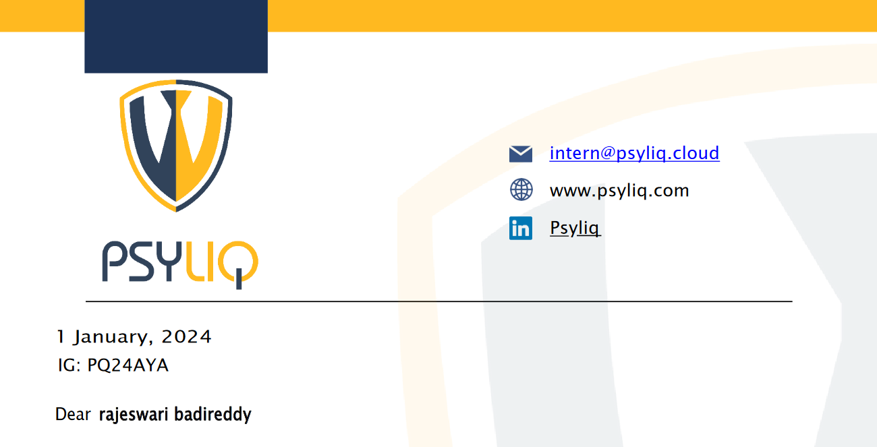



1. Schema Design: Given the provided dataset, create a Power BI data model with appropriate tables and relationships, considering the Distributor, Customer Name, City, and other relevant columns.

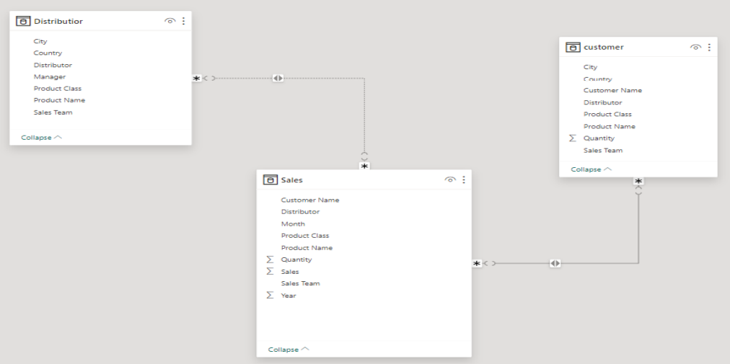

2. Relationships: Establish the necessary relationships between the tables in your data model. For instance, connect the "Sales" table to the "Customers" table.

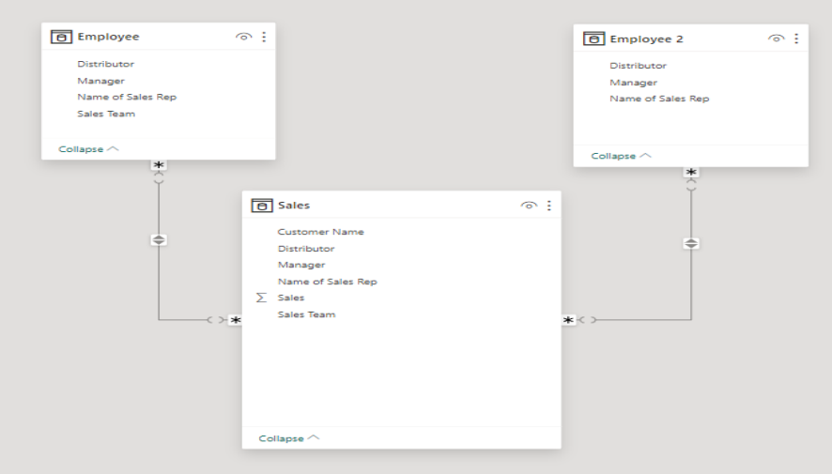

3. Role-Playing Dimensions: In your data model, demonstrate how you'd handle role-playing dimensions for "Sales Rep" and "Manager."

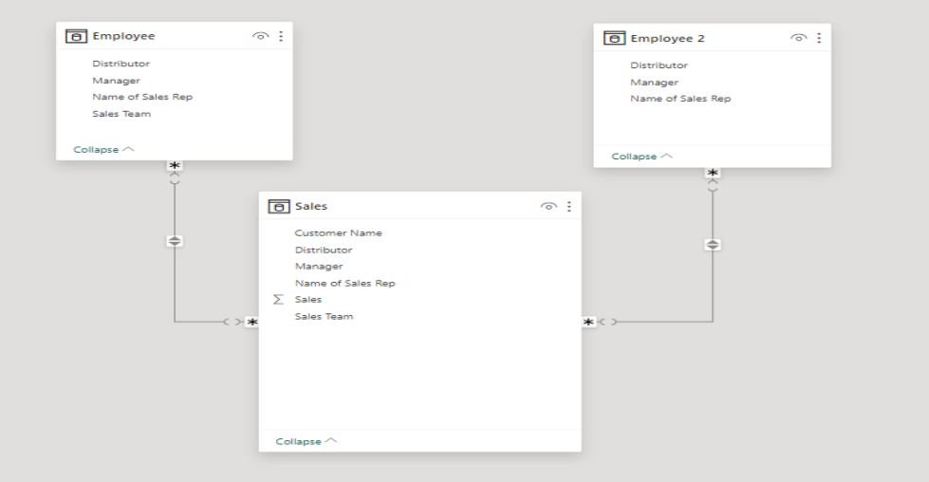

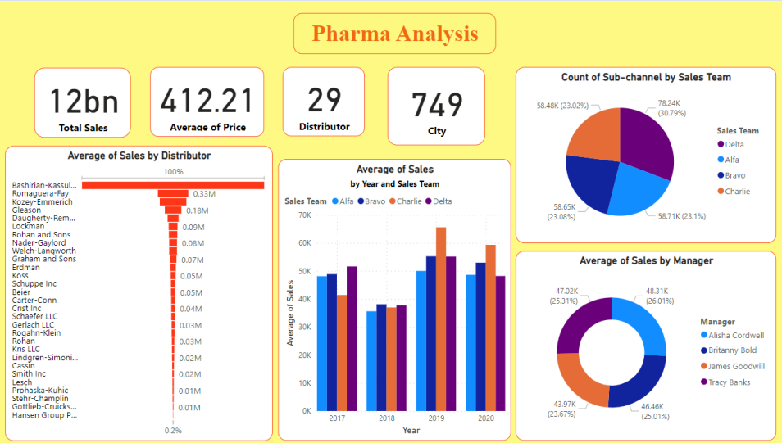

**THANK YOU..!! ☺**



**For this opportunity.**